

**A project Report on**

**JUSTDAIL WEBSITE USING AUTOMATION TOOL SELENIUM WEBDRIVER WITH JAVA.**

**By**

**Abarna.A**

**Batch-EON (2021-5533)**

**Under the Guidance of,**

**Amurta Deore Kachole**

**(Technical Trainer)**

**EduBridge India Pvt. Ltd.**

**Introduction:**

This Project aims to do overall testing like functional testing, GUI testing on justdail website to check quality of application using selenium web driver. It helps to improve quality of website and saves time for manually doing this testing.

In this project our main focus is to test the Bill and recharge payment Module. In this module have some options like Mobile recharge, Landline, Gas, Water also.

**Software Requirements:**

Operating System: Windows 7

Browser: Latest version of Google Chrome

Platform: Eclipse IDE

Automation Tool and Language: Selenium WebDriver, Java

Files: JDK, Selenium Jar files, Common IO file

**1.Bills and Recharge**

**TC01:** Launch the browser and justdail website

**Selenium WebDriver Test Script:**

System.*setProperty*("webdriver.chrome.driver","C:\\seleniumwebdriver\\chromedriver\\chromedriver.exe");

WebDriver driver=**new** ChromeDriver();

driver.get("https://www.justdial.com/sideMenu");

System.***out***.println("Launching website");

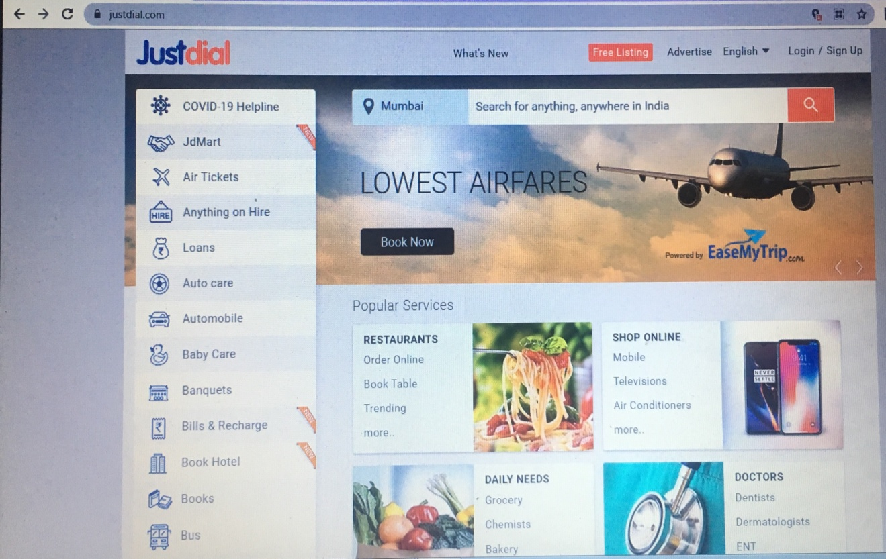

**TC02:** Maximize the window

**Selenium WebDriver Test Script:**

driver.manage().window().maximize();

System.***out***.println("Maximize the window");

**TC03:** To verify and display the go to the recharge page

**Selenium WebDriver Test Script:**

WebElement recharge=driver.findElement(By.*id*("hotkeys_text_9"));

recharge.click();

WebElementpaidOption=driver.findElement(By.*name*("mobile"));

paidOption.click();

System.***out***.println("readio button done");

WebElement mobileNumber=driver.findElement(By.*id*("num_rc_mob"));

mobileNumber.sendKeys("9790261996");;

System.***out***.println("mobile number send done");

city_1=driver.findElement(By.xpath("//*[@id=\"region_rc_mob\"]/span"));

city_1.click();

Select sc=new Select(city_1);

sc.selectByVisibleText("Chennai");*/

System.***out***.println("plan offer send done");

WebElement popular=driver.findElement(By.*id*("list_rc_mob_0list_rc_mob_0"));

Actions act=**new** Actions(driver);

act .moveToElement(popular).build().perform();

popular.click();

WebElement plan=driver.findElement(By.*xpath*("//*[@id=\"tpup1\"]/tbody/tr[3]/td[2]"));

Actions act11=**new** Actions(driver);

act11 .moveToElement(plan).build().perform();

plan.click();

System.***out***.println("plan selected done");

JavascriptExecutor js3=(JavascriptExecutor)driver;

js3.executeScript("window.scrollBy(0,1000)");

System.***out***.println("scroll down");

System.***out***.println("scroll done");

WebElement mail=driver.findElement(By.*id*("mail_rc_mob"));

mail.sendKeys("abarnaanish1999@gmail.com");

**TC04:** To verify and display the directly selected network

**Selenium WebDriver Test Script:**

directly select the network

Thread.*sleep*(2000);

WebElement network=driver.findElement(By.*xpath*("//*[@id=\"links_rc_mob\"]/ul/li[6]/a"));

network.click();

System.***out***.println("pnetwork select done");

//mobile number

WebElement num_rc_mob=driver.findElement(By.*id*("num_rc_mob"));

num_rc_mob.sendKeys("9865812627");

System.***out***.println("mobile no select done");

//other details

WebElement amt_rc_mob=driver.findElement(By.*id*("amt_rc_mob"));

amt_rc_mob.sendKeys("249");

WebElement mail1=driver.findElement(By.*id*("mail_rc_mob"));

mail1.sendKeys("abarnaanish1999@gmail.com");

**TC05:** To verify and display the go to the next page

**Selenium WebDriver Test Script:**

//go to the next page

WebElement nextPage=driver.findElement(By.*id*("button_rc_mob"));

Actions navi = **new** Actions( driver);

navi.moveToElement(nextPage).build().perform();

nextPage.click();

System.***out***.println("next page navigated done");

**TC06:** To verify and display the dth page

**Selenium WebDriver Test Script:**

WebElement dth=driver.findElement(By.*id*("rc_dth_tab"));

dth.click();

WebElement obj=driver.findElement(By.*id*("shwlnk_optr_rc_dth"));

obj.click();

WebElement obj1=driver.findElement(By.*xpath*("//*[@id=\"rc_dth_optr_link_24\"]/span/span[2]"));

Actions ac=**new** Actions(driver);

ac.moveToElement(obj1).build().perform();

ac.click()

**TC07:** To verify and display the payments orders

**Selenium WebDriver Test Script:**

WebElement PaymentOptions=driver.findElement(By.*xpath*("/html/body/div[4]/div/ul/li[2]/a"));

PaymentOptions.click();

**TC08:** To verify and display the contact us

**Selenium WebDriver Test Script:**

WebElement contactus=driver.findElement(By.*xpath*("/html/body/div[4]/section[4]/div[13]/ul/li[5]/a"));

Actions act_9=**new** Actions(driver);

act_9.moveToElement(contactus).build().perform();

contactus.click();

System.***out***.println("contact us done");

**TC09:** To verify that browser is able to close.

**Selenium WebDriver Test Script:**

driver.close();